EXPERIMENT NO 11
Create a Static Website and Containerize, Build & Serve it using Docker.
Tasks:
1. Create a Simple Static Website (index.html file) with basic
HTML content.
2. Write/create a Dockerfile to serve the website using Nginx.
3. Build the Docker Image
4. Run the container:
5. Access the Website using a Browser

1. Aim
To create a simple static website using HTML, containerize the website using Docker, build a Docker image with Nginx, run the Docker container, and access the website through a web browser.
2. Procedure
Step 1: Create a project folder
- Open Command Prompt.
- Create a folder named static-website.
- Navigate into the folder.
mkdir static-website
cd static-website
Step 2: Create the static website
- Create a file named index.html.
- Add the following HTML code.
<!DOCTYPE html>
<html>
<head>
<title>My Static Website</title>
</head>
<body>
<h1>Welcome to My Website</h1>
<p>This website is created using HTML and served using Docker.</p>
</body>
</html>
Step 3: Create a Dockerfile
- Create a file named Dockerfile without any file extension.
- Add the following instructions.
FROM nginx:latest

COPY index.html /usr/share/nginx/html/index.html

EXPOSE 80

CMD ["nginx", "-g", "daemon off;"]
Step 4: Build the Docker image
- Open Command Prompt inside the project folder.
- Execute the following command to build the Docker image.
docker build -t static-website .
The image will be created successfully.
Step 5: Run the Docker container
Execute the following command to create and run the container.
docker run -d -p 8080:80 --name static-container static-website
Here:
- -d – Runs the container in the background.
- -p 8080:80 – Maps host port 8080 to container port 80.
- --name – Assigns a name to the container.
- static-website – Specifies the Docker image.
Step 6: Verify the running container
Execute:
docker ps
This command displays the list of running containers.
Step 7: Access the website using a browser
- Open Google Chrome or any web browser.
- Enter the following URL:
http://localhost:8080
- The static website will be displayed successfully.
3. Expected Output
My Static Website
Running
Welcome to My Website
This website is created using HTML and served using Docker.
Browser URL: http://localhost:8080

OUTPUT:
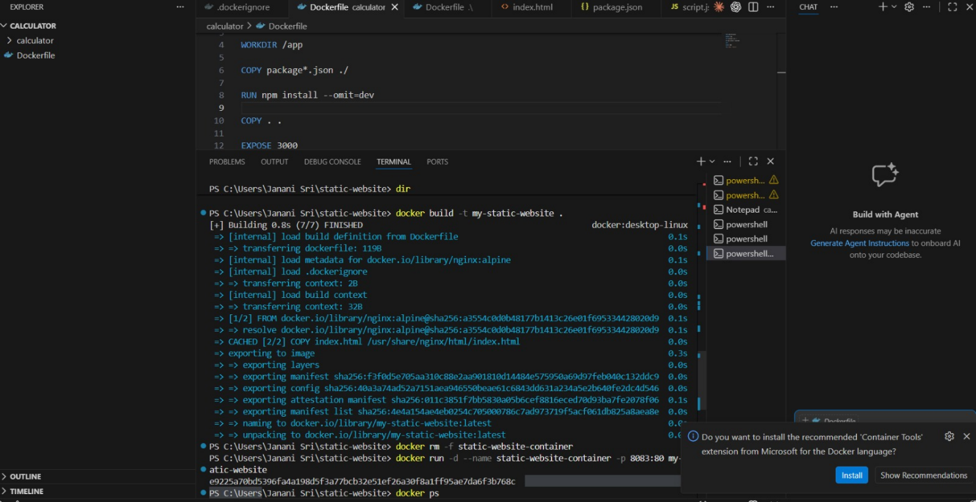

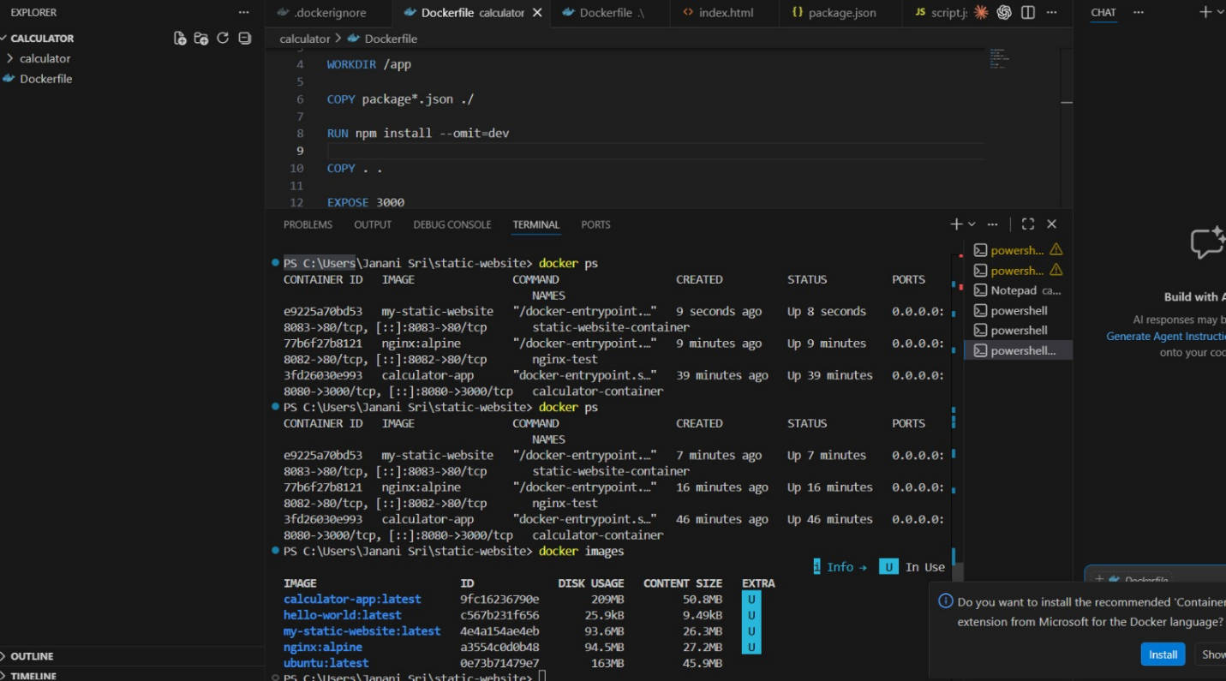

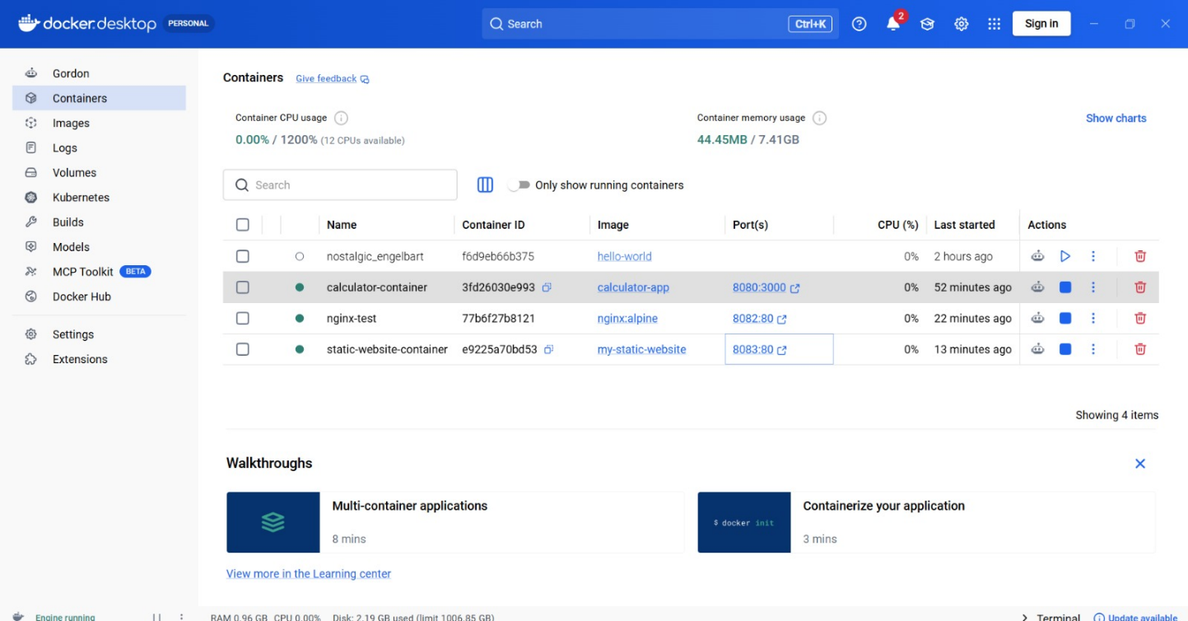

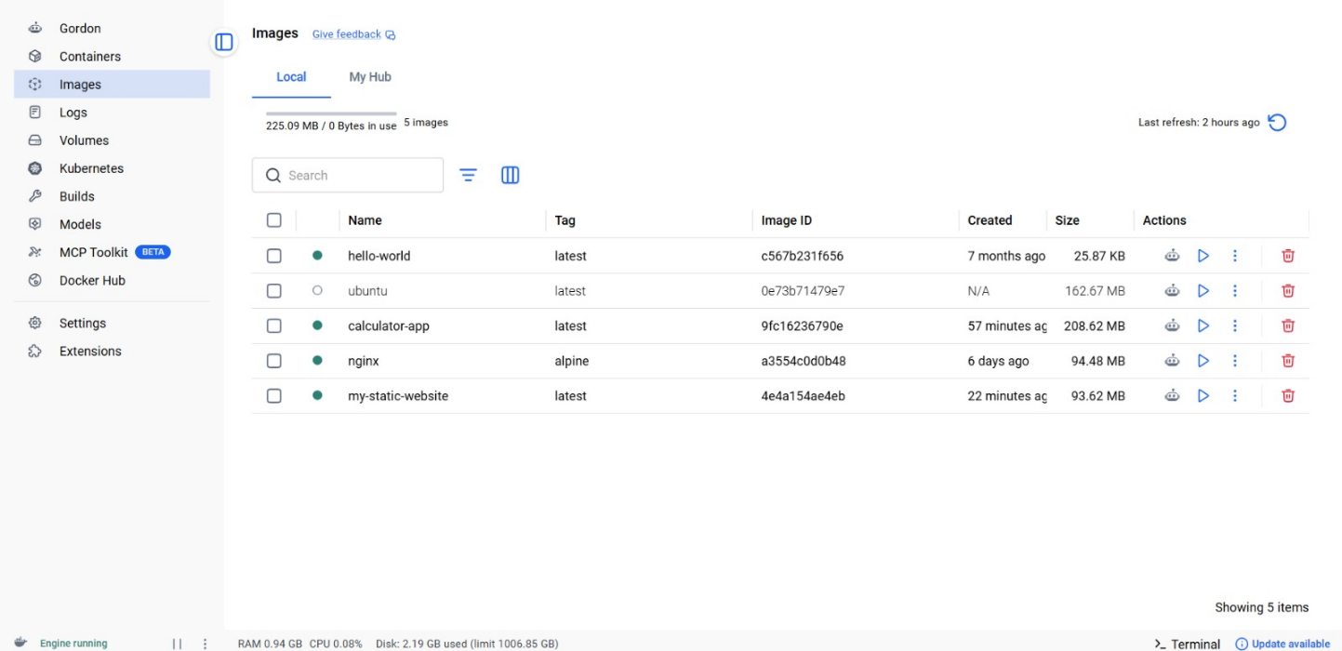



4. Result
Thus, a static website was successfully created using HTML, containerized using Docker, and served using the Nginx web server. The Docker image was built successfully, the container was executed, and the website was accessed through a web browser using http://localhost:8080.
The experiment was completed successfully.

